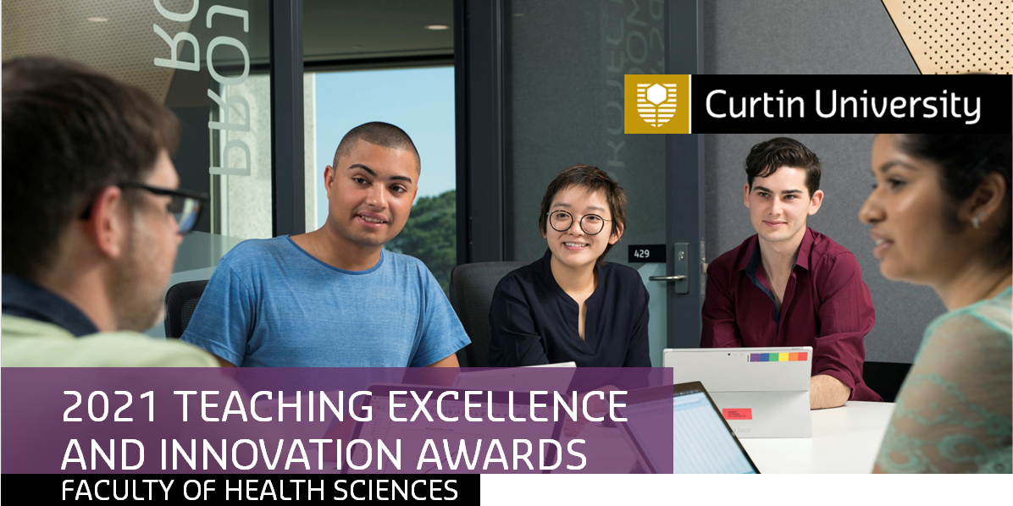

LIFETIME ACHIEVEMENT AWARD
This award recognises individuals in the Faculty of Health Sciences who are reaching retirement and have demonstrated sustained excellence in student learning. As a general rule, only one Lifetime Achievement Award will be presented annually.

NOMINATIONS
1. A School Executive or the Dean Learning and Teaching may nominate an individual for this award.
2. The award recognises sustained service to the Faculty of Health Sciences through learning and teaching activities.

CRITERIA
- Sustained contributions to the facilitation of learning in the Faculty for at least 20 years of full time, part time or sessional employment at Curtin University. The 20 years do not have to be continuous.
- Leadership and mentorship of less experienced teachers to assist them to grow their teaching and/or SoLT capacity.
- Collaboration with other staff within the Faculty contributing to teaching excellence.

Recipients of the FHS Lifetime Achievement Award are ineligible for nomination for a second time.

Name of nominee, title and host School |  | Signature of nominee
Role in the Faculty
Total Years of Service |  | Start Date
Name of Nominator, title and host School |  | Signature of nominator

A supporting statement by the nominator will be used to assess the selection criteria (approx. 500 words):

SUBMISSION
By 10.00am on Monday, 25 October 2021, please email as a pdf document (one electronic copy only, hard copy not required) to cl.doherty@curtin.edu.au.

PRIVACY STATEMENT Personal information collected is handled in accordance with the Australian Privacy Principles. Further information on privacy at Curtin University is available at: http://rim.curtin.edu.au/privacy/

